Wealth Transformation Preserving Shape

The problem with fitting the wealth distribution is that it has a long right-tail and zero/negative values. Here we describe how we use a generalization of the inverse hyperbolic sine transform, presented in MacKinnon and Magee (1990) (MM). The major results of this

- Estimation for the generalized inverse hyperbolic sine transformation is implemented in STATA in ghreg.ado, using Nelder-Mead optimization.
- The parameters are more difficult to estimate the closer the shift parameteris to zero.
- The distribution of simulated wealth is similar (although statistically different) to that of actual wealth, with the exception of those values above the 99th percentile, when using data from the 1992 HRS for those aged 50-55.

Description and Implementation

With a given variable of interest y, the hyperbolic sine transform is
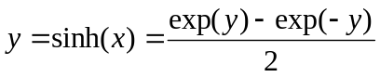 (1)
The inverse of the hyperbolic sin transform is

. (2)

In stata, this function is implemented in _gh.ado as an addition to egen; the syntax for which is: egen newvar = h(oldvar) in stata. (file _gh.ado)

To generalize this transformation, we first allow for a shape parameter θ,

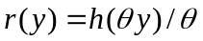. (3)

Such that we can specify the regression model as

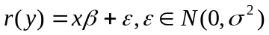. (4)

We further generalize the transformation by introducing a location parameter such that the new transformation becomes
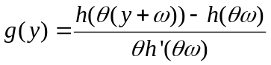 (5)
where 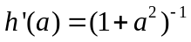. This function is implemented in _ggh.ado as en extension to egen, and is specified as egen newvar = gh(oldvar), theta() omega().

We can specify (4) in terms of the transformation g. The shape parameters can be estimated from the concentrated likelihood for θ and ω. Estimation follows from maximization of equation (41) in MM. Having identified θ and ω, we can then retrieve β and σ. The likelihood function (41) is not globally concave, and so estimation is implemented using Nelder-Mead optimization, rather than Stata’s standard likelihood maximization routine. This is formulated in ghreg.ado, and is specified as ghreg [varlist]. This function returns estimates for all of the above parameters, as well as an estimate of the variance/covariance matrix of these estimates.

Upon estimation, we can simulate
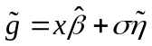 (6)

where is a standard normal draw. Given this draw, we can retransform using (5) and (1)
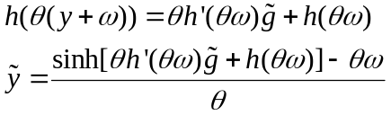

This inverse transformation is given in _ginvgh.ado as an extension to egen, whose syntax is egen newvar = invgh(oldvar), theta() omega(). The complete simulation is implemented in ghreg_p.ado, and is a post-estimation command for ghreg. The syntax is predict newvar, simu.

Simulation and Application to Wealth in the HRS

To determine how well the parameters can be estimated, we simulate 10,000 observations with a known θ and ω (this is done for various θ and ω combinations). We then use ghreg to estimate θ and ω from the simulated data. As can be seen in Exhibit 1, below, we find that as θ tends toward zero, identification is increasingly difficult.

Exhibit 1: Comparison of Estimated and Simulated Parameter Estimation for the Inverse Hyperbolic Sine Transformation
Simulated Theta | Estimated Theta | Simulated Omega | Estimated Omega
0.10 | 0.00 | 0.00 | 0.29
0.10 | 0.00 | 0.50 | 0.29
0.25 | -0.17 | 0.00 | 0.13
0.25 | 0.19 | 0.50 | 0.88
0.50 | 0.45 | 0.00 | 0.00
0.50 | 0.45 | 0.50 | 0.62
0.75 | 0.71 | 0.00 | 0.01
0.75 | 0.71 | 0.50 | 0.55
1.00 | 0.96 | 0.00 | 0.01
1.00 | 0.96 | 0.50 | 0.54

Lastly, we use household wealth data from the Health Retirement Survey for 1992, among people aged 50-55, and estimate the parameters using the following specification

Using these data, we estimate parameters of -0.069 for θ, and 1.016 for ω, and 374.561 for the variance of the error term. Using these parameters, we create a simulated wealth, and compare it with the original. We present two different comparisons, first a kernel density estimate of the distribution of wealth and simulated wealth, and second, a number of summary statistics on the distributions.
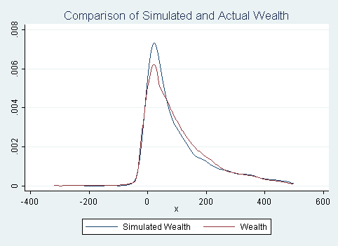

We can see that the simulated distribution of wealth is similar to that of actual wealth, although does not match perfectly. There are a couple of reasons why this may be the case. First, the specification of our model may not be complete. Second, the estimated parameter for θ is close to zero, and given our results from the simulation above, it is particularly difficult to identify the parameters when θ is close to zero.

Exhibit 2: Comparison of Wealth and Simulated Wealth
Percentile | Wealth | Simulated Wealth
1% | -29.3 | -20.2
5% | -0.2 | -3.6
10% | 0.9 | 4.2
25% | 24.4 | 23.1
50% | 80.5 | 71.9
75% | 188.1 | 198.6
90% | 384.7 | 477.3
95% | 650.0 | 812.4
99% | 2,132.3 | 2,155.6
Mean | 189.1 | 213.4
Variance | 196,685.5 | 324,277.3

Through much of the distribution, the simulated and actual values of wealth are similar. A Kolmogorov-Smirnov test rejects the hypothesis that the simulated and actual wealth distributions are the same at the 99% level. This test also reject when restricting the population to those less than the 99th percentile.

The above programs use a series of mata codes in their implementation, betas.mo, gsinh.mo, gsinhinv.mo, lnll_ahg.mo inuncll_ahg.mo opti.mo, opti_unc.mo, and ssr.mo, all of which are created by create_mata_codes.do. These files do not require user interaction, and are called upon as necessary in maximizing the likelihood and creating the simulated values.

